Guvi Task 2

Create a file with .txt extension (/home/demo.txt). Change the permission set of that file, so that any user can read it, group can read/write & owner can read/write/execute it.

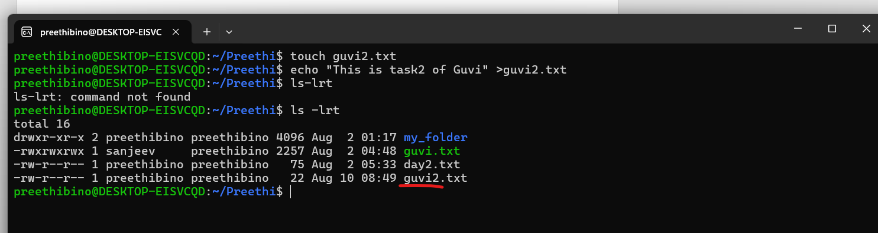

To change the permisiions

R=4 w=2 x= 1

Owner—rwx =4+2+1 =7

Group rw- =4+2+0 =6

Others :r-- =4+0+0 =4

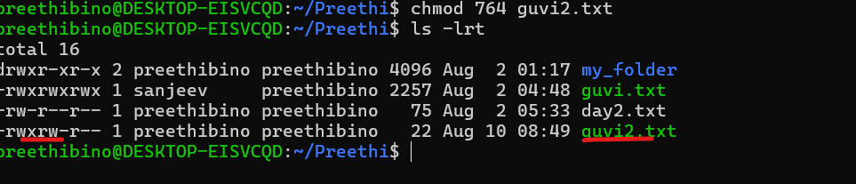

Other way is u=rwx,g=rw.o=r

